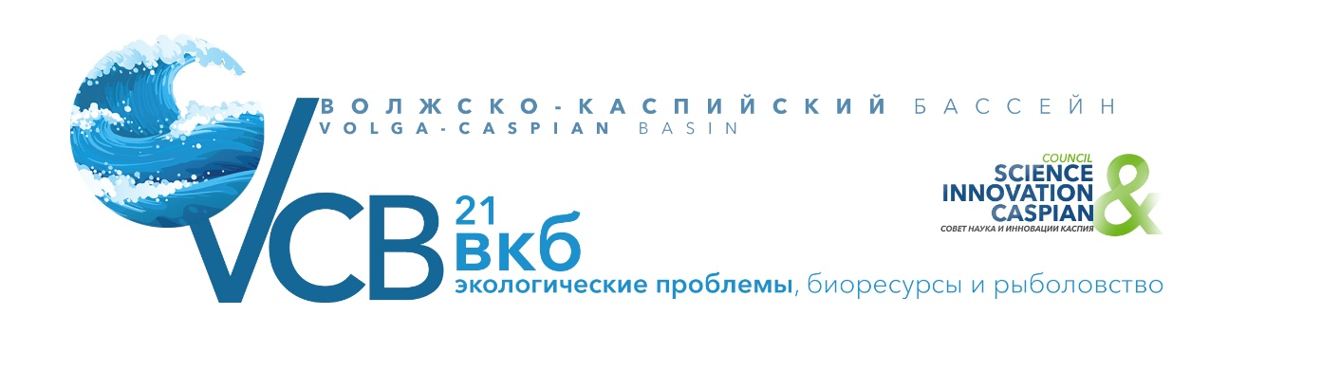

INFORMATION ABOUT THE FORMS AND CONDITIONS OF PARTICIPATION
IN THE CONFERENCE.

Dates: April 28-29, 2021, 10: 00-18: 00.
Working languages of the Conference: Russian and English
Forms of participation in the Conference: full-time and remote.
Location face to face meetings and online broadcast of the Conference: Moscow, A.N. Severtsov Institute of Ecology and Evolution of the Russian Academy of Sciences.
Requirements for the report/presentation:
* The duration of the report is not more than 15 minutes
* The duration of the speech is not more than 7 minutes
• The language in which the presentation can be made: Russian or English
• The topic of the presentation should coincide with the topic of the session
* The presentation may be accompanied by a slide show
Those who wish to speak at the Forum should:
* Send an application to the Organizing Committee, indicating the session at which you plan to speak - by March 15, 2021
* Send the topic of the speech (title of the report) to the Organizing Committee - by March 15, 2021
* a color photo of the speaker in the format of at least 3 x 4 centimeters in electronic form (bmp, jpg or tiff file format)
• information about the speaker (short summary) to be presented by the Moderator of the speaker's session to other Forum guests
* abstracts of the speech (until March 20)
• Send the presentation (slides) to the Organizing Committee in electronic form in ppt or pptx file format - by April 10, 2021
Requirements for submitting abstracts:
* Abstracts (provided only in electronic form (doc file format), in the name of the files indicate the full name of the speaker of the section. (For example: Sergey Ivanov Петрович.doc)
* Abstract text without hyphenation and extra spaces in the format: single spacing, Times New Roman 10pt font, width alignment
* Margins: left, right, top and bottom – 15 mm.
* Article title-TIMES NEW ROMAN FONT, 10 PT, UPPERCASE, BOLD, CENTERED
• On the next line after the title – the full name of the authors separated by commas, starting with the underlined full name of the speaker. First the initials, then the last name of the authors
• Each report in Russian must be accompanied by an abstract in English (Times New Roman, 10 Pt), up to 500 words in length, including the title of the report, the full name of the authors, the organization, and e-mail.
• Each report in English must be accompanied by an abstract in Russian (Times New Roman, 10 Pt) of up to 500 words, including the title of the report, the full name of the authors, the organization, and e-mail.
• In the text of the report, use quotation marks like "...»

